**MA5750: APPLIED STATISTICS**

**ASSIGNMENT 4**

**E Naveen**

**ME16B077**

**9.1**

**R Code:**

# Set of values of pi for Monte-Carlo Simulation  
pi_values = seq(from = 0.1, to = 0.9, by = 0.1)  
  
# Initialize a few required variables with zeros  
bias_f = numeric(length = length(pi_values))  
bias_b = numeric(length = length(pi_values))  
variance_f = numeric(length = length(pi_values))  
variance_b = numeric(length = length(pi_values))  
MS_f_1 = numeric(length = length(pi_values))  
MS_b_1 = numeric(length = length(pi_values))  
MS_f_2 = numeric(length = length(pi_values))  
MS_b_2 = numeric(length = length(pi_values))  
  
# Iterate over the different values of pi  
for (pi_index in 1:length(pi_values)) {  
   
 # Initialize a few required variables with zeros  
 pi_f = numeric(length = 5000)  
 pi_b = numeric(length = 5000)  
 square_dist_f = numeric(length = 5000)  
 square_dist_b = numeric(length = 5000)  
   
 # (i)  
 # Iterate over 5000 instances for Monte-Carlo Simulations  
 for (N in 1:5000) {  
 # Generate uniform random varible from 0 to 1.  
 pi_montecarlo = runif(10, 0, 1)  
 # y is the count of r.v.'s out of 10 from above that are less than  
 # the pi value.  
 y = sum(pi_montecarlo < pi_values[pi_index])  
 n = 10  
 # Store the Frequentist and Bayesian estimates for Pi.  
 # (ii)  
 pi_f[N] = (y)/(n)  
 # (iii)  
 pi_b[N] = (y+1)/(n+2)  
 # Calculate squared errors of estimates from actual value.  
 square_dist_f[N] = (pi_f[N] - pi_values[pi_index])**2  
 square_dist_b[N] = (pi_b[N] - pi_values[pi_index])**2  
 }  
   
 # Find Bias and Variance of sample distribution.  
 # (iv)  
 bias_f[pi_index] = mean(pi_f) - pi_values[pi_index]  
 bias_b[pi_index] = mean(pi_b) - pi_values[pi_index]  
 # (v)  
 variance_f[pi_index] = var(pi_f)  
 variance_b[pi_index] = var(pi_b)  
 # (vi)  
 # Find Mean squared Error using Bias and Variance.  
 MS_f_1[pi_index] = (bias_f[pi_index]**2) + (variance_f[pi_index])  
 MS_b_1[pi_index] = (bias_b[pi_index]**2) + (variance_b[pi_index])  
 # Find Mean Squared Error by taking average of squared errors.  
 MS_f_2[pi_index] = mean(square_dist_f)  
 MS_b_2[pi_index] = mean(square_dist_b)  
   
}  
  
# Print the Mean squared error calculated by the two methods to check they are same.  
cat('Frequentist \n','First Method', MS_f_1,'\nSecond Method', MS_f_2)

**## Frequentist   
## First Method** 0.009073815 0.01553711 0.02138228 0.02376475 0.02461492 0.02406081 0.02107821 0.01574315 0.009191838   
**## Second Method** 0.009072 0.015534 0.021378 0.02376 0.02461 0.024056 0.021074 0.01574 0.00919

cat('Bayesian \n','First Method', MS_b_1,'\nSecond Method', MS_b_2)

**## Bayesian   
## First Method** 0.01068348 0.01316132 0.01601214 0.01677108 0.01709369 0.01693779 0.01564098 0.01378607 0.01071878   
**## Second Method** 0.01068222 0.01315917 0.01600917 0.01676778 0.01709028 0.01693444 0.01563806 0.01378389 0.0107175

* The mean squared of the estimator produce the same result when done using either bias and variance (or) mean of squared error as seen in the output printed above.
* The small changes in values are purely due to the numerical approximation done by the computer.

**(b)**

**R Code:**

# Plot Biases of the two estimators versus pi  
plot(pi_values, bias_b, type='b', col = 'red', main = 'Bias of estimators vs. pi',  
 xlab = 'Pi', ylab = 'Bias')  
lines(pi_values, bias_f, type='b', col='blue', lty=2)  
legend(x= "topright", legend=c("bayesian","frequentist"),  
 col=c("red", "blue"), lty=1:2, cex=0.8)

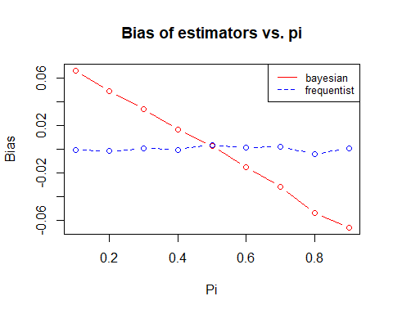

1. By observation we can see that Frequentist estimator is Unbiased owing to values of Bias close to 0.
2. On the other hand, the Bayesian estimate is Biased and we see a downwards trend with $π$. This is in accordance to the theory that we studied earlier.

**(c)**

**R Code:**

# Plot mean squared errors of the two estimators versus pi  
plot(pi_values, MS_f_1, type='b', col = 'red', main = 'Mean squared errors vs. pi',  
 xlab = 'Pi', ylab = 'Mean Squared Error')  
lines(pi_values, MS_b_1, type='b', col='blue', lty=2)  
legend(x= "topright", legend=c("frequentist","bayesian"),  
 col=c("red", "blue"), lty=1:2, cex=0.8)

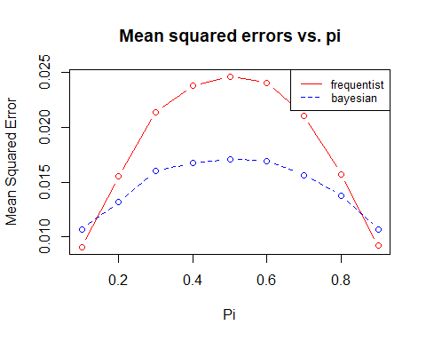

1. The Graph plotted above does resemble the one (Fig 9.2) from the textbook.
2. When $π$ takes on values in the range $[0.2,0.8]$ the Bayesian estimator have smaller mean squared error than that of Frequentist estimator.

**10.2**

Jeffrey’s prior for Poisson parameter $μ$ is given by,

$$g\left(μ\right)=μ^{-\frac{1}{2}}$$

We know any gamma distribution is given by,

$$gamma\left(x;r,v\right)=\frac{v^{r}x^{r-1}e^{-vx}}{Γ(r)}$$

Comparing the above two we have, $r=\frac{1}{2}$ and $v=0$. Hence $gamma(1/2,0)$ will give this prior.

**R Code:**

# Import the necessary library  
library('Bolstad')

##   
## Attaching package: 'Bolstad'

## The following objects are masked from 'package:stats':  
##   
## IQR, sd, var

# Store the observation (data) in y  
y = c(3,4,3,0,1)  
  
# (b)  
# Use posgamp command to find posterior for the given prior distribution  
result = poisgamp(y, 1/2, 0)

## Summary statistics for data  
## ---------------------------  
## Number of observations: 5   
## Sum of observations: 11   
##   
## Summary statistics for posterior  
## --------------------------------  
## Shape parameter (r): 11.5   
## Rate parameter (v): 5   
## 95% credible interval for mu: [1.17, 3.81]

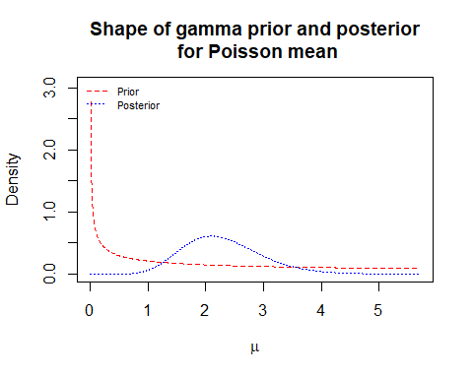

plot(result$mu, result$posterior, type='l', main = 'Posterior Distribution',  
 xlab = 'mu', ylab = 'pdf')

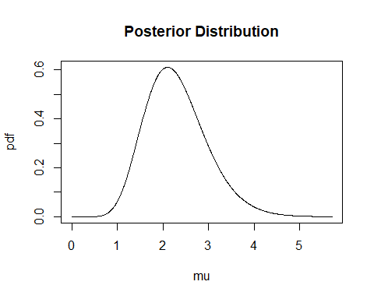

**R Code:**

# (c)  
# Calculate Mean and Median  
E_posterior = sintegral(result$mu, result$mu*result$posterior, n.pts = length(result$mu))  
median_posterior = result$mu[which.max(result$posterior)]  
# Print Mean and Median  
cat('Posterior\nMean =', E_posterior$value, '\nMedian =', median_posterior)

## Posterior  
## Mean = 2.299401   
## Median = 2.100347

* Posterior Mean = 2.299401
* Posterior Median = 2.100347

**R Code:**

# (d)  
# Find 95% Bayesian credible interval using 'which.max' function  
cdf_1 = sintegral(result$mu, result$posterior, n.pts = length(result$mu))  
cdf = cdf_1$cdf  
lower_bound = cdf$x[with(cdf,which.max(x[y<=0.025]))]  
upper_bound = cdf$x[with(cdf,which.max(x[y<=0.975]))]  
cat(paste("Approximate 95% Bayesian credible interval using 'which.max' function: \n[", round(lower_bound, 4),  
 " ", round(upper_bound, 4), "]\n", sep = ""))

**## Approximate 95% Bayesian credible interval using 'which.max' function:   
## [1.1603 3.8002]**

# Find 95% Bayesian credible interval using 'approxfun' function  
Finv = approxfun(cdf$y,cdf$x)  
lower_bound = Finv(c(0.025))  
upper_bound = Finv(c(0.975))  
cat(paste("Approximate 95% Bayesian credible interval using 'approxfun' function: \n[", round(lower_bound, 4),  
 " ", round(upper_bound, 4), "]\n", sep = ""))

**## Approximate 95% Bayesian credible interval using 'approxfun' function:   
## [1.166 3.8047]**

* 95% Bayesian Credible interval = [1.166 3.8047]

**10.6**

**(a)**

**R Code:**

# Import the necessary library  
library('Bolstad')

##   
## Attaching package: 'Bolstad'

## The following objects are masked from 'package:stats':  
##   
## IQR, sd, var

# Store the observation (data) in y  
# NOTE: This time we'll be taking 10 observations as mentioned in Q)10.6  
y = c(3,4,3,0,1,1,2,3,3,6)  
  
mu_values = seq(from = 0, to = 8, by=0.0001)  
  
mu_prior = rep(0,length(mu_values))  
mu_prior[mu_values<=2] = mu_values[mu_values<=2]  
mu_prior[mu_values>2 & mu_values<=4] = 2  
mu_prior[mu_values>4 & mu_values<=8] = 6 - mu_values[mu_values>4 & mu_values<=8]/2  
mu_prior[mu_values>8] = 0  
  
plot(mu_values,mu_prior, type='l')

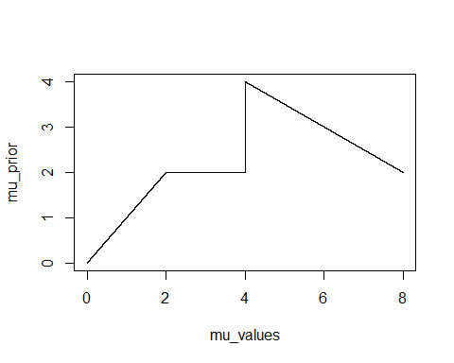

# (a)  
# Use posgcp command to find posterior for the given prior distribution  
result = poisgcp(y = y, density = "user", mu = mu_values, mu.prior = mu_prior)

## Summary statistics for data  
## ---------------------------  
## Number of observations: 10   
## Sum of observations: 26

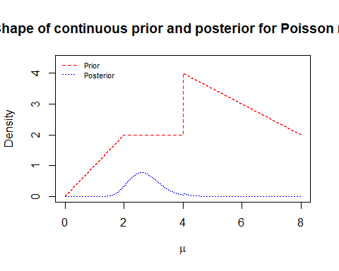

plot(result$mu, result$posterior, type='l', main = 'Posterior Distribution',  
 xlab = 'mu', ylab = 'pdf')

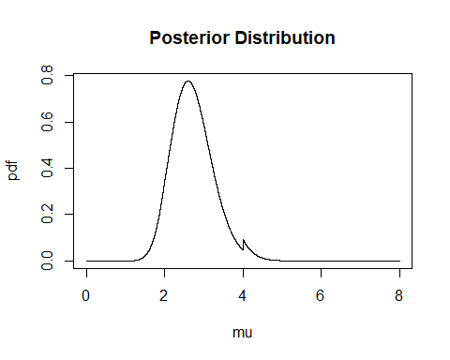

**(b)**

# (b)  
# Calculate Mean, Median and Standard deviation  
E_posterior = sintegral(result$mu, result$mu*result$posterior, n.pts = length(result$mu))  
median_posterior = result$mu[which.max(result$posterior)]  
# Print Mean and Median  
cat('Posterior\nMean =', E_posterior$value, '\nMedian =', median_posterior)

## Posterior  
## Mean = 2.724635   
## Median = 2.6

variance = sintegral(result$mu, ((result$mu-E_posterior$value)^2)*result$posterior, n.pts = length(result$mu))  
# Print Standard Deviation  
cat('\nStandard Deviation =', variance$value^0.5)

##   
## Standard Deviation = 0.5369072

* Posterior Mean = 2.724635
* Posterior Median = 2.6
* Posterior Standard Deviation = 0.5369072

**(c)**

# (c)  
# Find 95% Bayesian credible interval using 'approxfun' function  
cdf_1 = sintegral(result$mu, result$posterior, n.pts = length(result$mu))  
cdf = cdf_1$cdf  
Finv = approxfun(cdf$y,cdf$x)  
lower_bound = Finv(c(0.025))  
upper_bound = Finv(c(0.975))  
cat(paste("Approximate 95% Bayesian credible interval using 'approxfun' function: \n[", round(lower_bound, 4),  
 " ", round(upper_bound, 4), "]\n", sep = ""))

## Approximate 95% Bayesian credible interval using 'approxfun' function:   
## [1.8114 3.975]

* 95% Bayesian Credible interval = [1.8114 3.975]